Data Warehousing and Business Intelligence

Assignment 02

IT22550262



Table of Contents

Data Source for the Assignment 2

SSAS Cube Implementation 3

Demonstration of OLAP Operations 17

Roll-Up 21

Drill-Down 22

Slicing 23

Dicing 23

Pivoting – Changing perspective of analysis 24

Power BI Reports 25

Report 1 26

Report 2 27

Report 3 28

Report 4 29

# Data Source for the Assignment

The Data warehouse is based on a Hospital Management System, it has four Dimensions tables and a Fact table. The fact table quantifies the billing of patients. The Dimension tables include: DimPatients, DimDoctors, DimPrescription, DimDate which assist in FactBilling Fact table. These Dimension tables include most important attributes that are required to Analysis tasks in this scenario. Below Entity Relational diagram shows how they interact with each other.

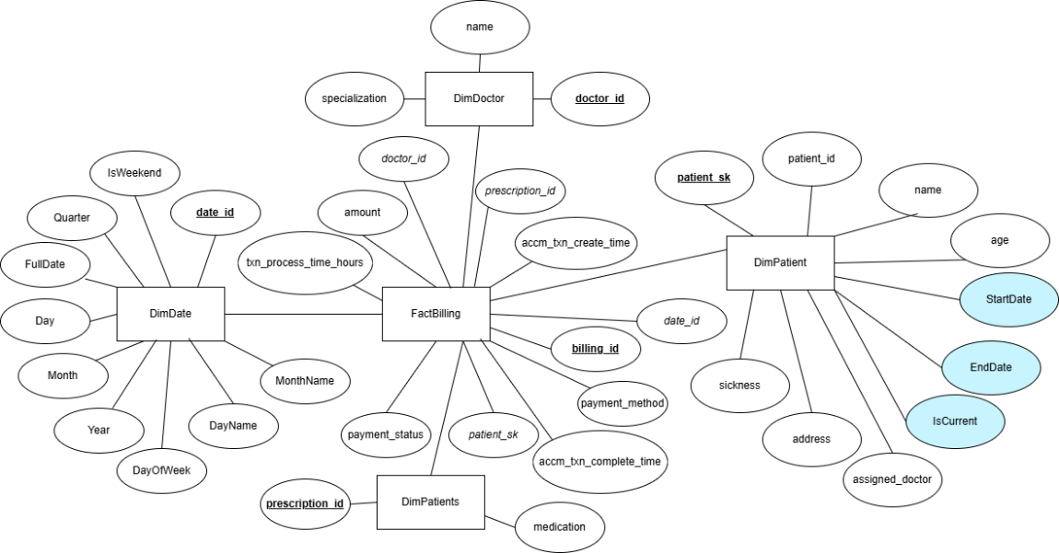

The blue coloured attributes are related to SCD (Slowly Changing Dimension). The measurable attributes are Billing amount and txn_processing_hours.

# SSAS Cube Implementation

In Visual Studio I created an Analysis and Multidimensional Project named HelathCareCube  
The main objective of creating a cube is to pre-aggregate and organize datasets into multidimensional structures which facilitate fast decision making.

First, in Data Sources of the project, pointed it to the Data Warehouse  
  
(Adding connection details)   
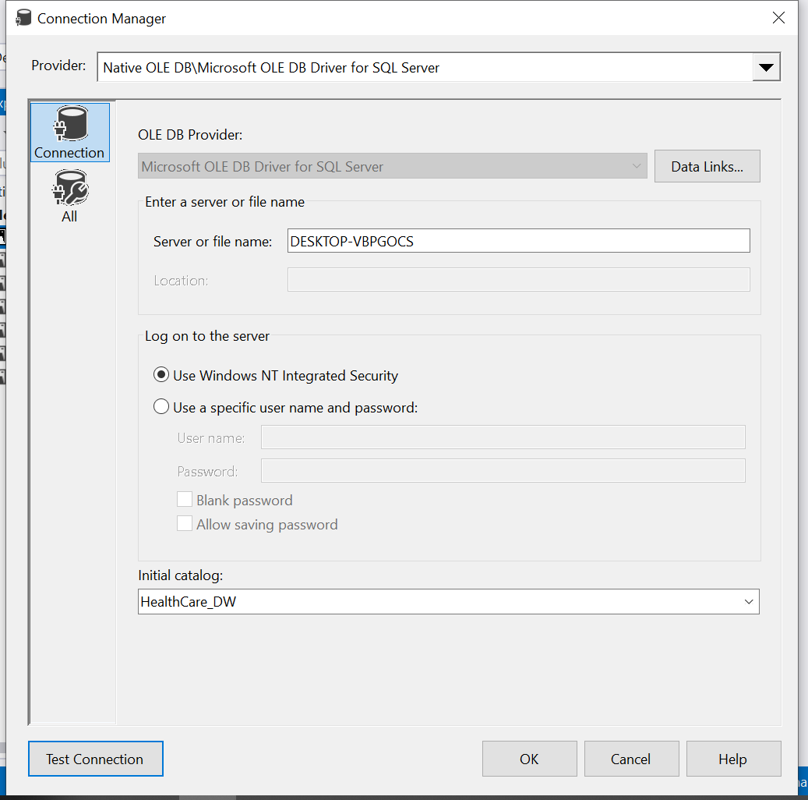

Then tested out connection to ensure it connected successfully

Next in Data Source view, added all the tables from the Warehouse Database. These are the underlying resources which cube is fed on.  
  
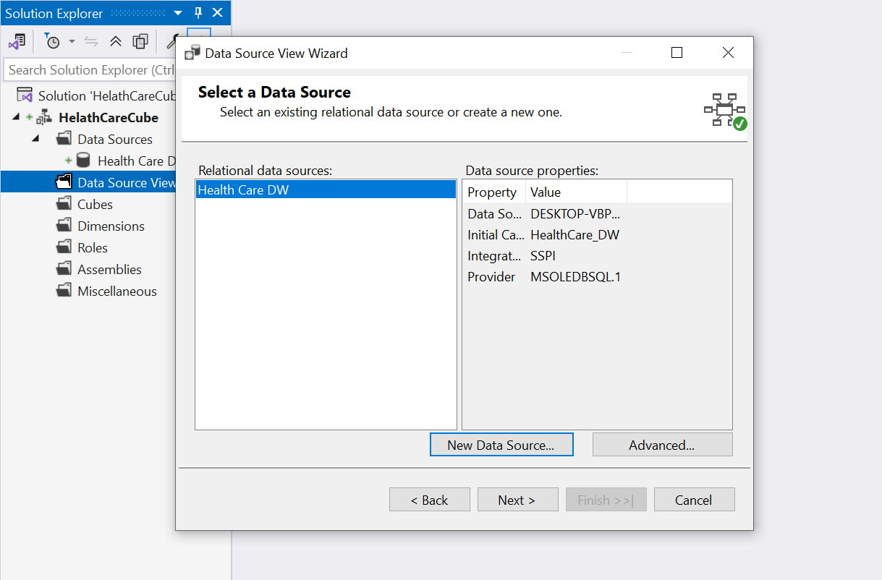

Selected the Data warehouse database and all the Dimension & Fact tables  
  
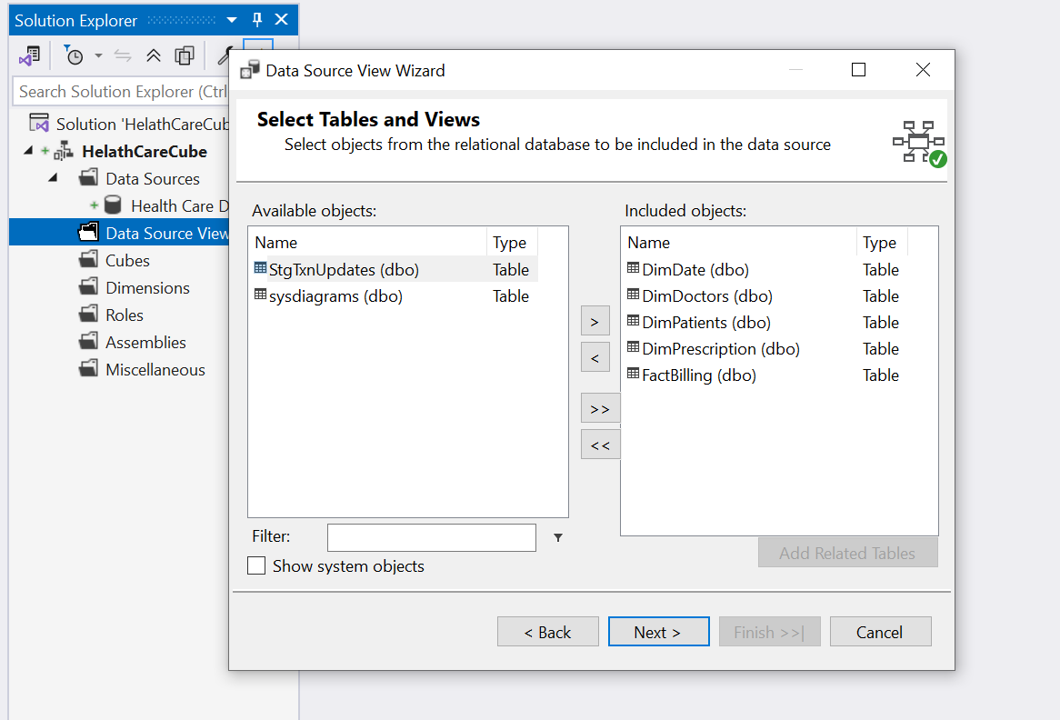

Then all the data sources could be observed as loaded successfully.

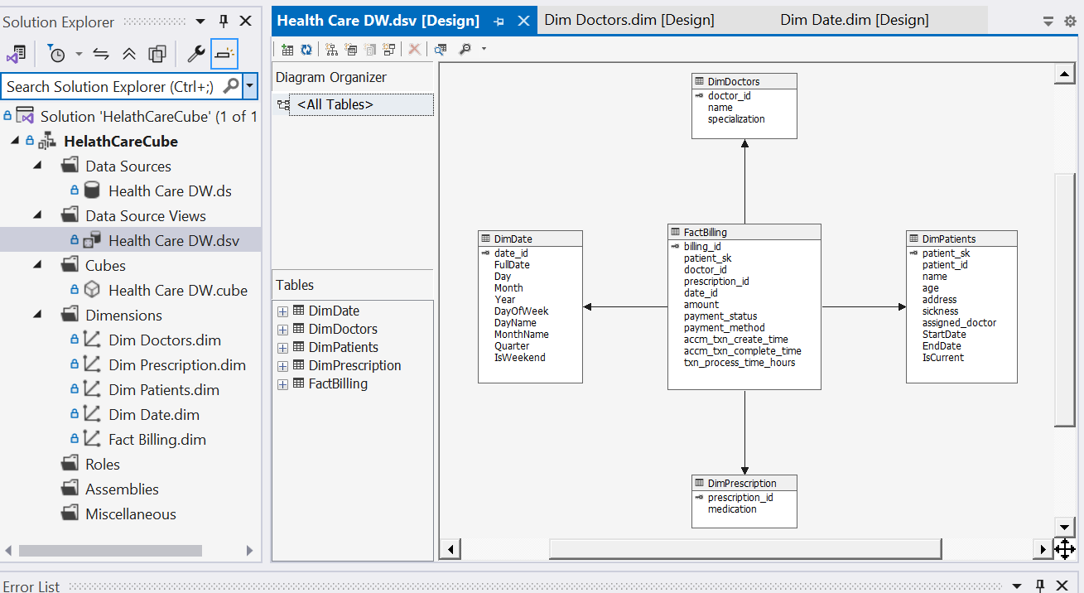  
  
  
Then created dimensions from the tables. These are the descriptive, categorical data which can be used to analyse and slice measures.  
  
Added the necessary configurations  
  
  
  
For the DimDate Dimension, I selected FullDate as showing value referring the date_id  
  
  
then selected all dimensions attributes as they will be important for decision making purposes.  
  
  
Likewise selected all in DimDoctors

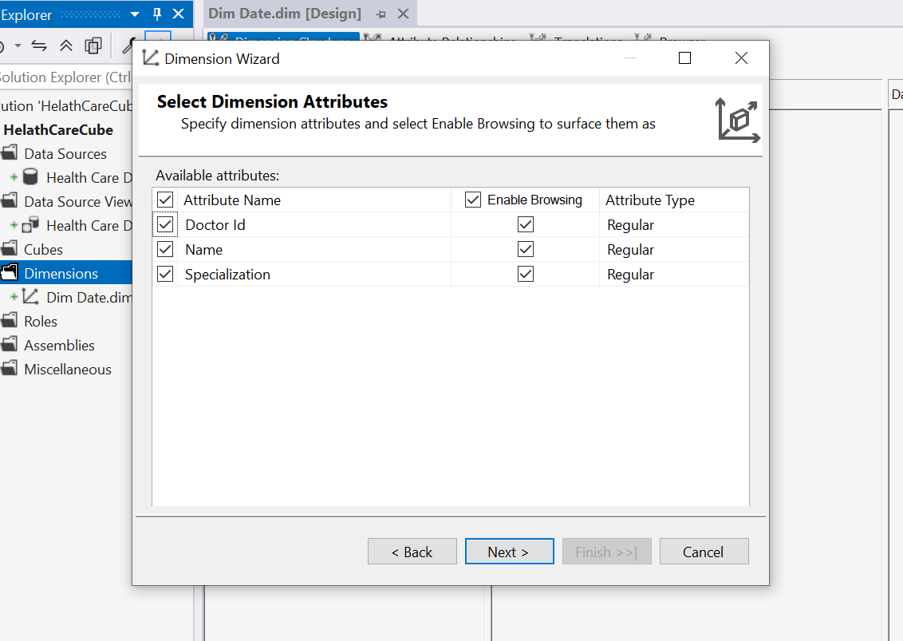

Selected all from DimPrescription  
  
Selected all for DimPatients  
  
Then built a user hierarchy using DimDate

1. Year
2. Quarter
3. Month (Month name)

had to configure attribute relationships  
  
In attribute relationships configured it as needed.  
  
Since month name maybe ordered by alphabetical order, selected it to order by attribute key.

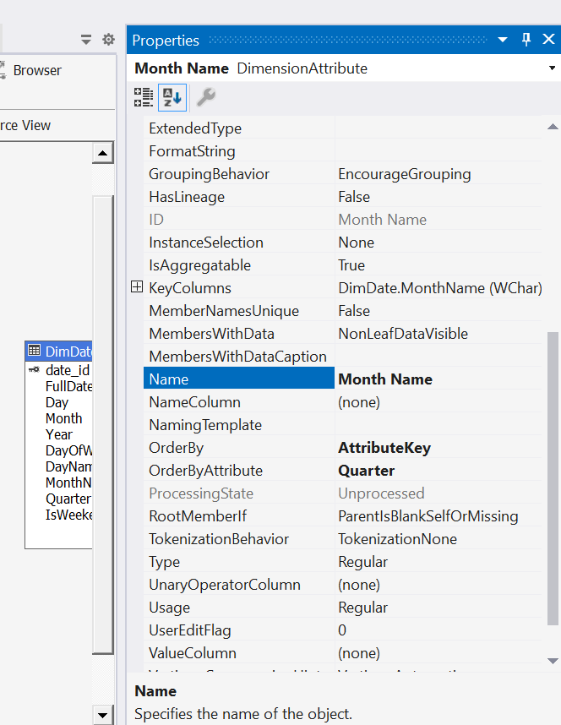  
  
  
Final DimDate dimensions looked like this 👇  
  
Then I started defining a cube using Cube Wizard.  
  
  
Selected appropriate measures from the fact table (FactBilling)  
  
Added dimensions including previously created Date Hierarchy as needed  
  
The cube view looked like this 👇  
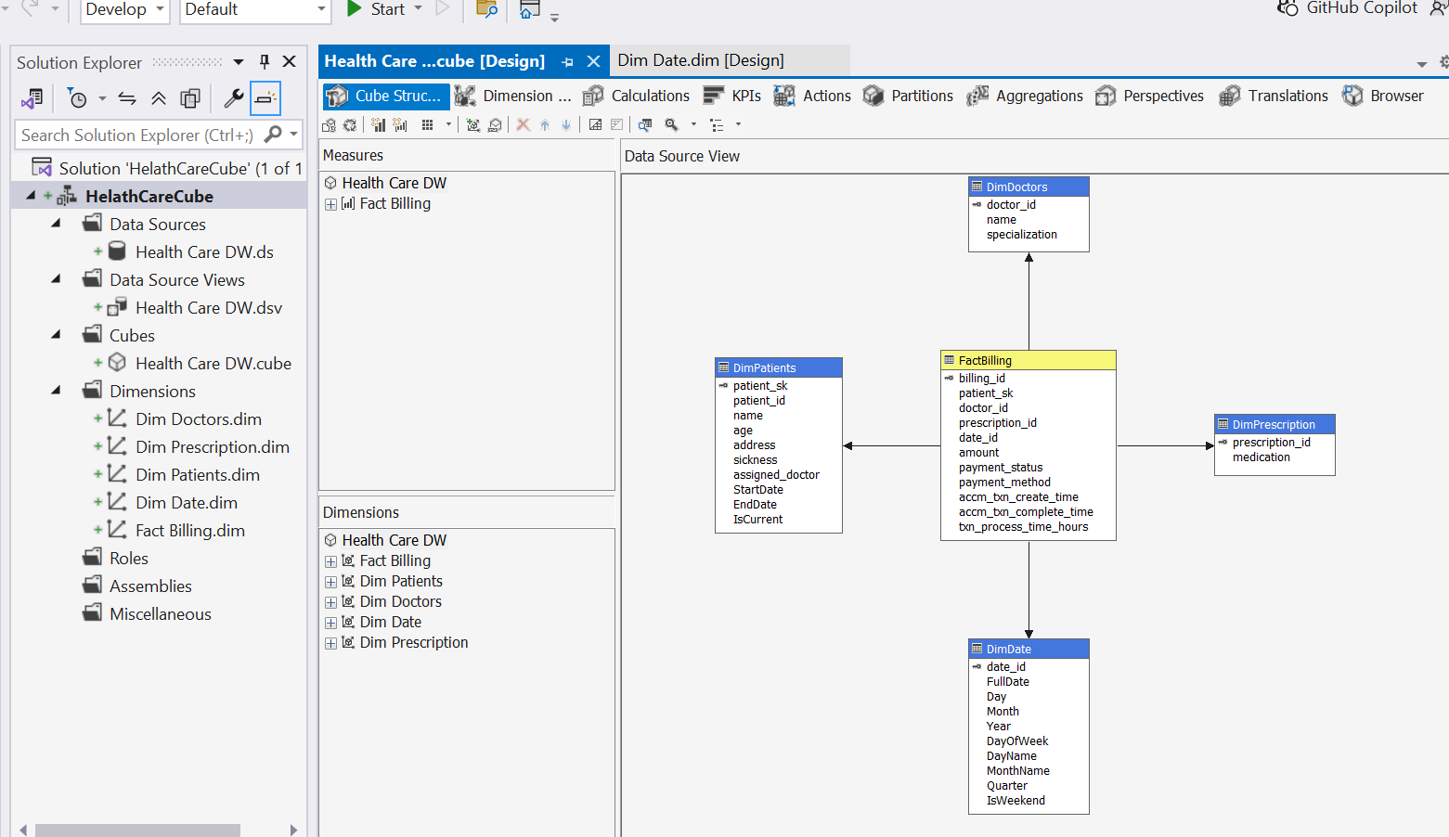  
  
Verified and configured relationships between fact and dimension tables using the dimension usage tab.  
  
Configured deployment properties including target server and database settings  
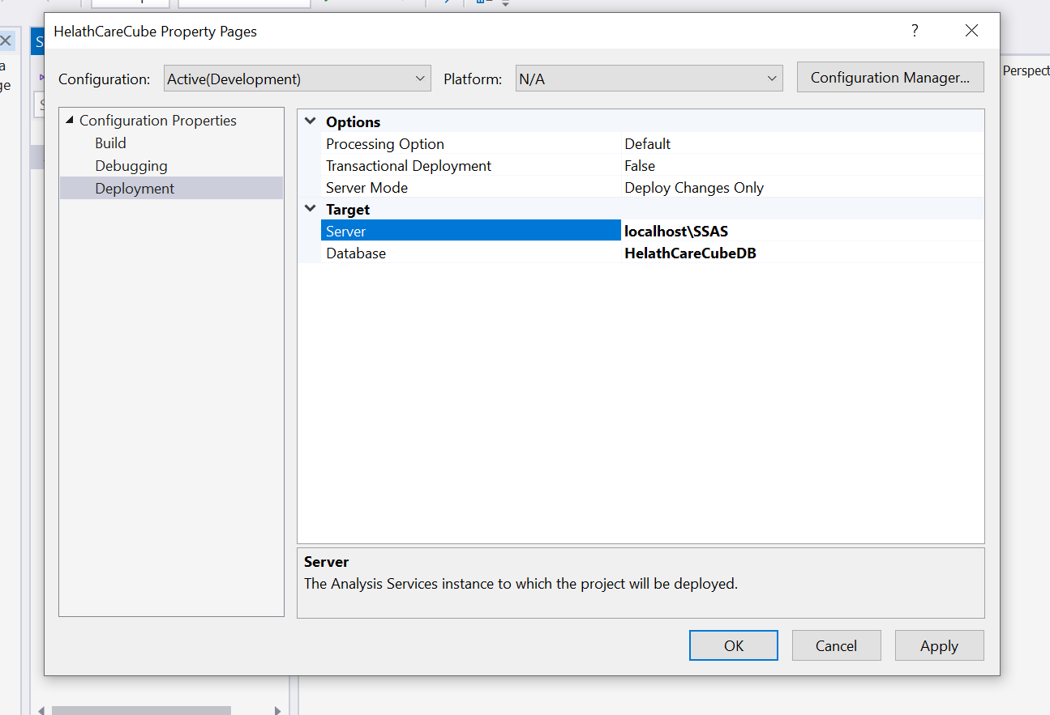  
  
Then built the cube and started debugging, had an issue due to missing SQL Server Analysis Services (SSAS) instance, resolved it by installing required service.

Faced a connection issue due to access limitation, created a new SQL server login using windows authentication via SSMS to enable SSAS to communicate with SSMS

An error detected when deploying due to duplicate Quarter and Month Names   
(Q1 as 1 appearing in two different years, ‘January’ in two different years)

Resolved it by modifying hierarchy to include Year context for Quarter and Month levels, so there will be unique scenarios  
  
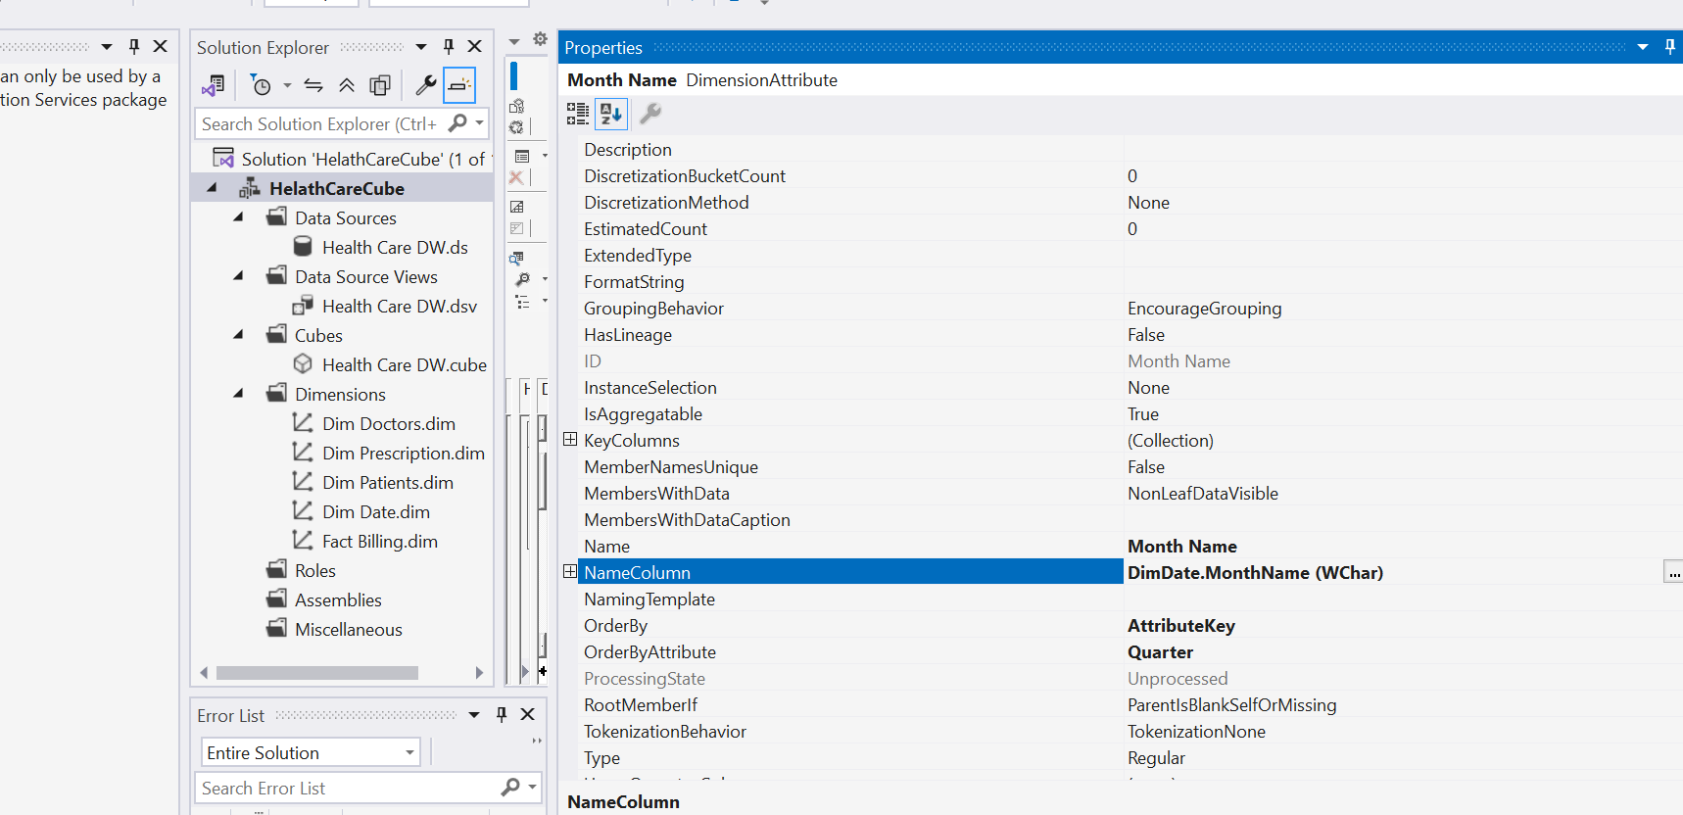  
  
Then a successful deployment happend  
  
# Demonstration of OLAP Operations

Here I opened a blank Excel file

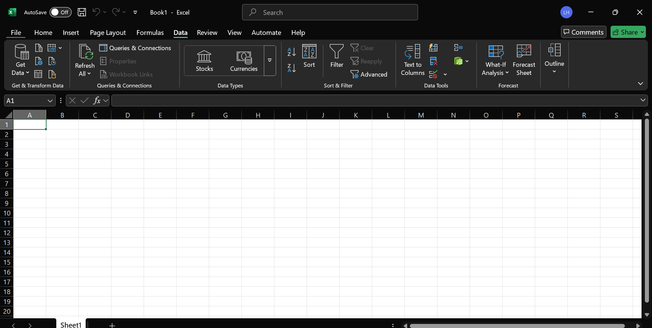  
  
Then in Data tab > Get Data function to connect to SSAS cube via the Analysis Services

Entered relevant data server and database details, selected the cube and loaded the data  
  
  
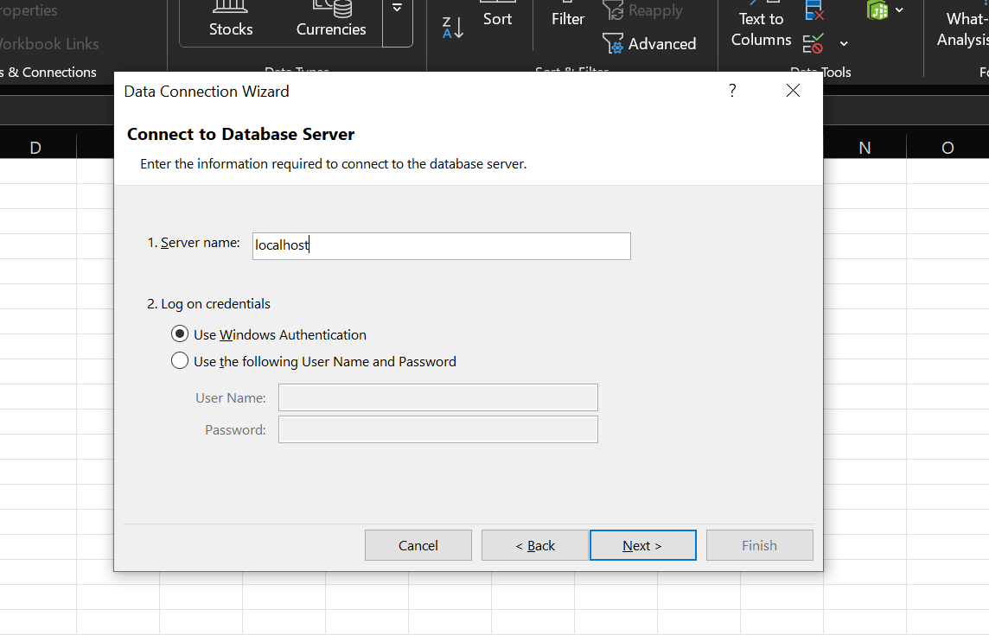  
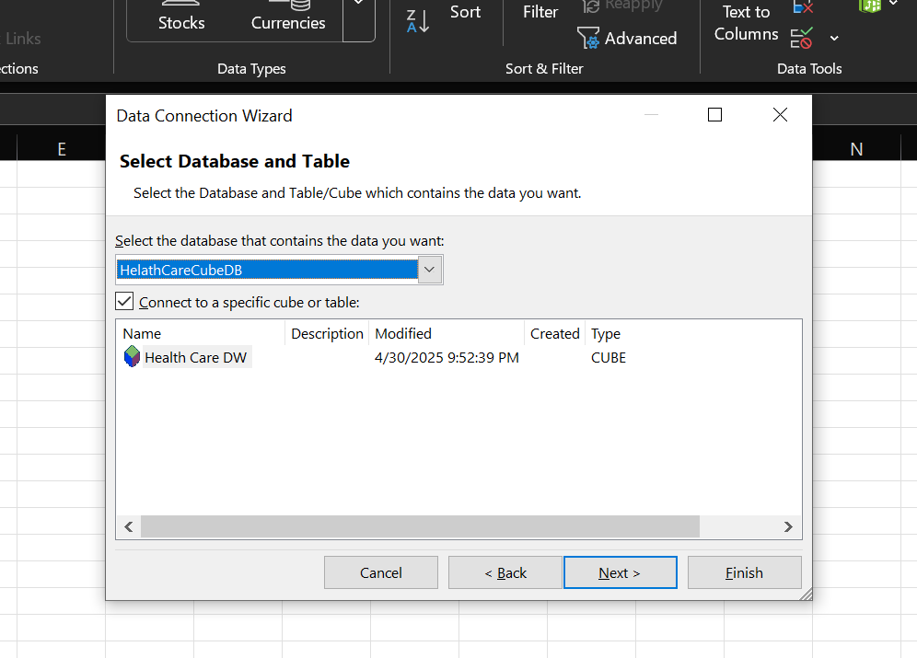  
  
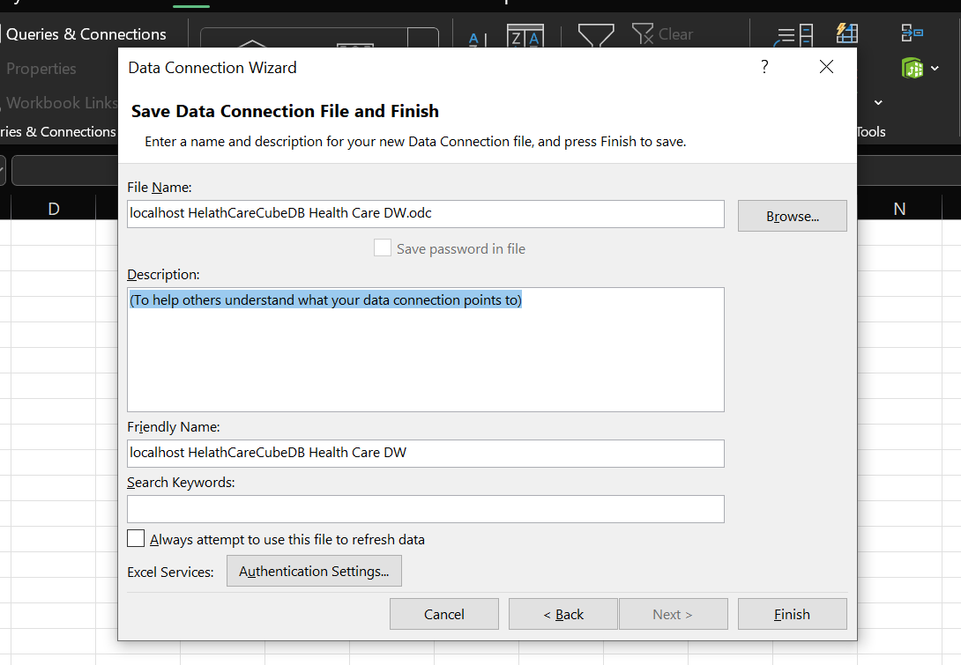  
  
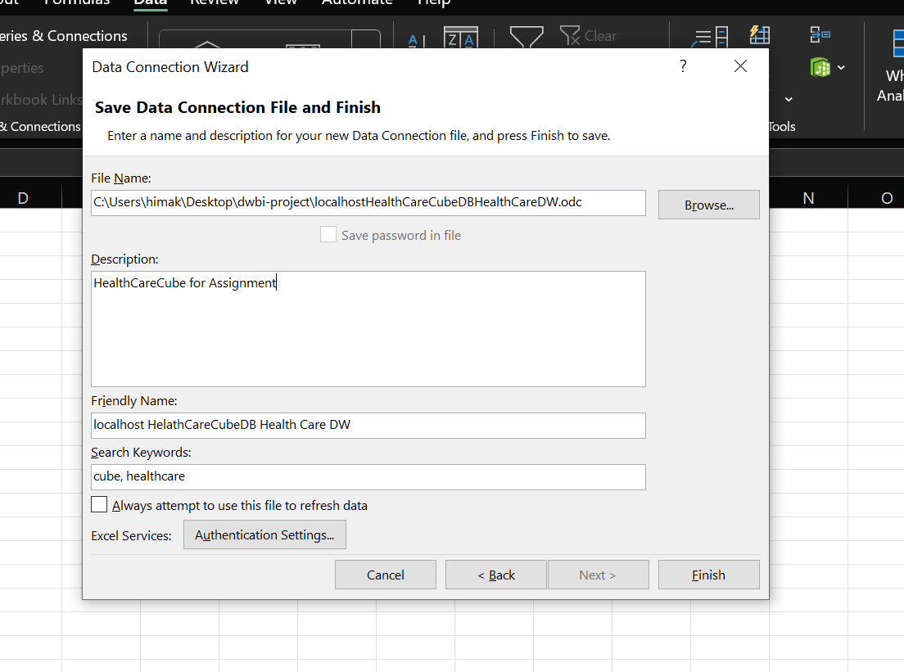

Then started demonstrating OLAP operations, created a Pivot table using the connected cube to enable multi-dimensional analysis  
  
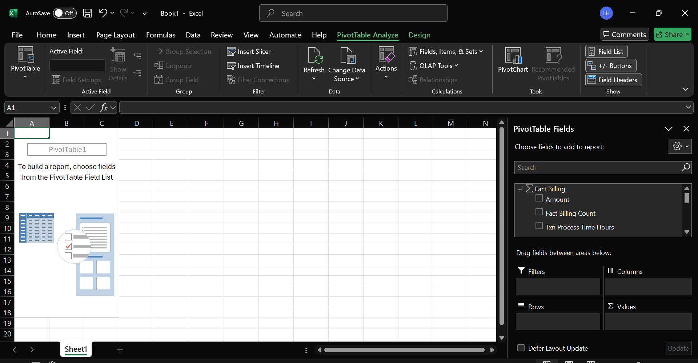

Roll-Up

Demonstrated roll-up using Date hierarchy (Year > Quarter > Month) to aggregate values at higher levels  
  
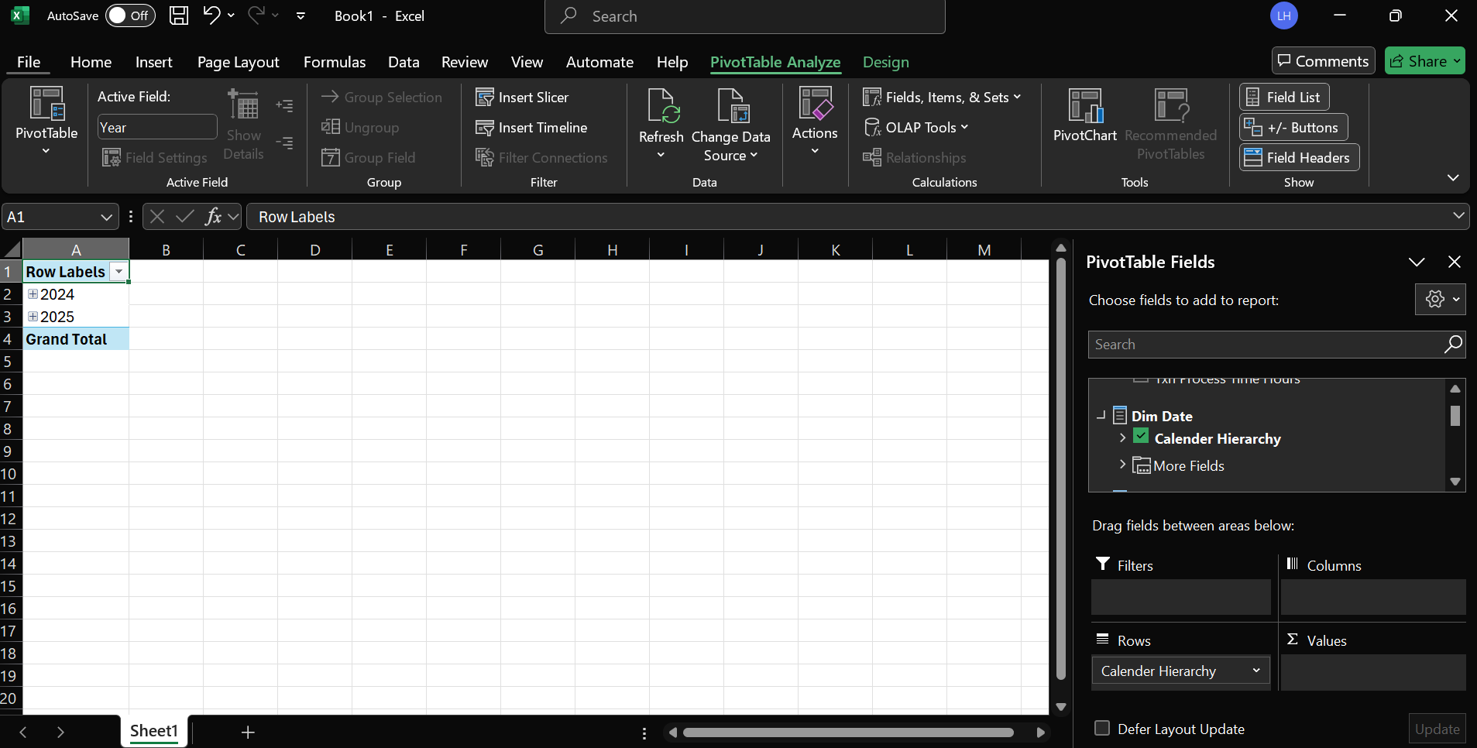  
  
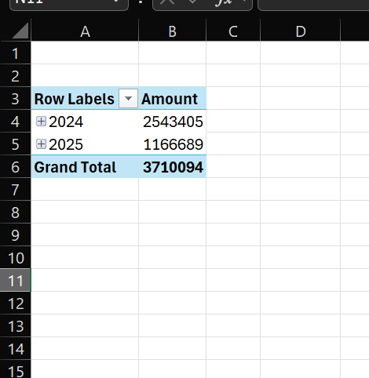

## Drill-Down

Expanded the Date hierarchy to explore detailed data at the Month and Quarter levels  
  
  
  
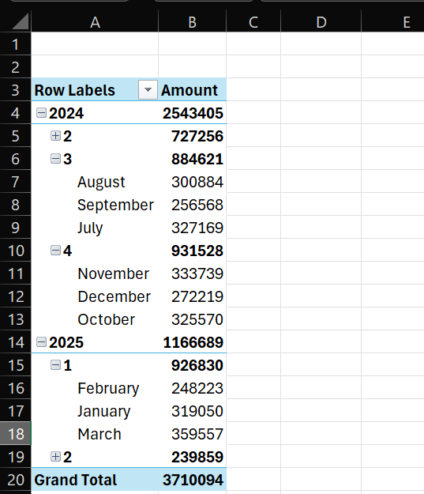

## Slicing

Inserted a slicer and added doctor name to it view metrics specified to each doctor  
  
  
  
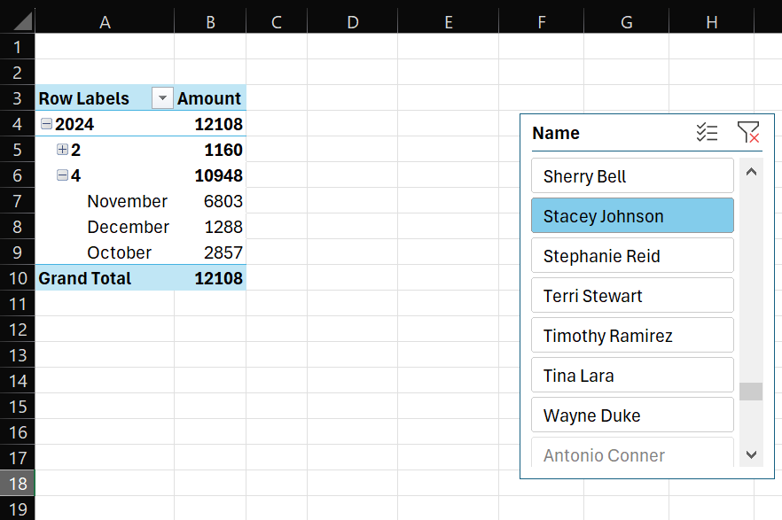

Dicing  
  
included both Doctor name and Specialization in rows/columns to analyse combined dimensions  
  
  
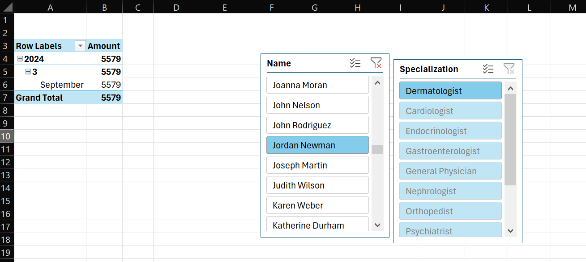

Pivoting – Changing perspective of analysis  
  
Rearranged the Pivot table by switching the Data hierarchy from rows to columns and added Doctor name to rows, showcasing different perspectives  
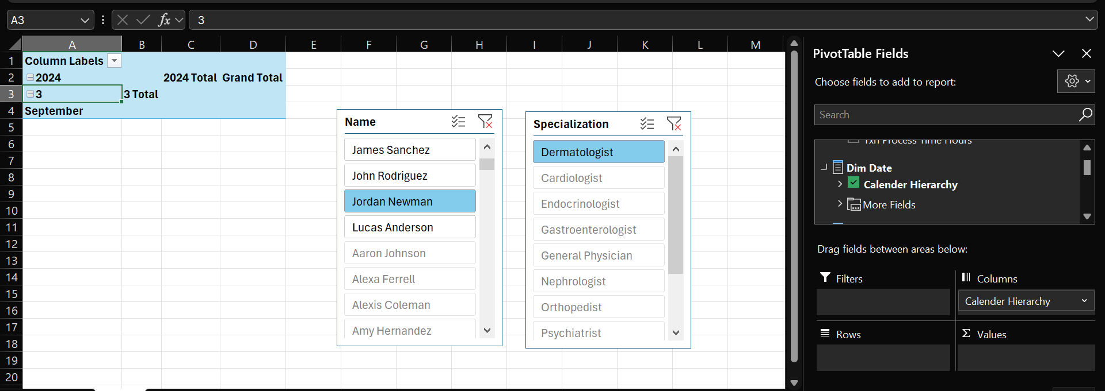  
  
  
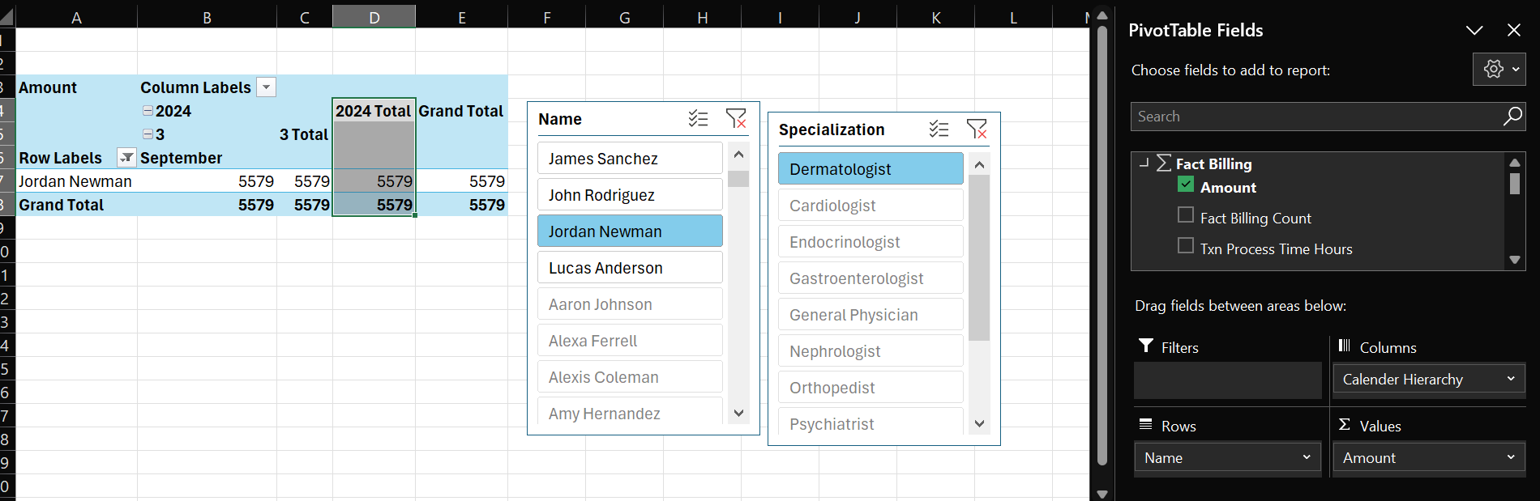

# Power BI Reports

Launched Power BI Desktop and selected Get Data and selected SQL Server Analysis services  
  
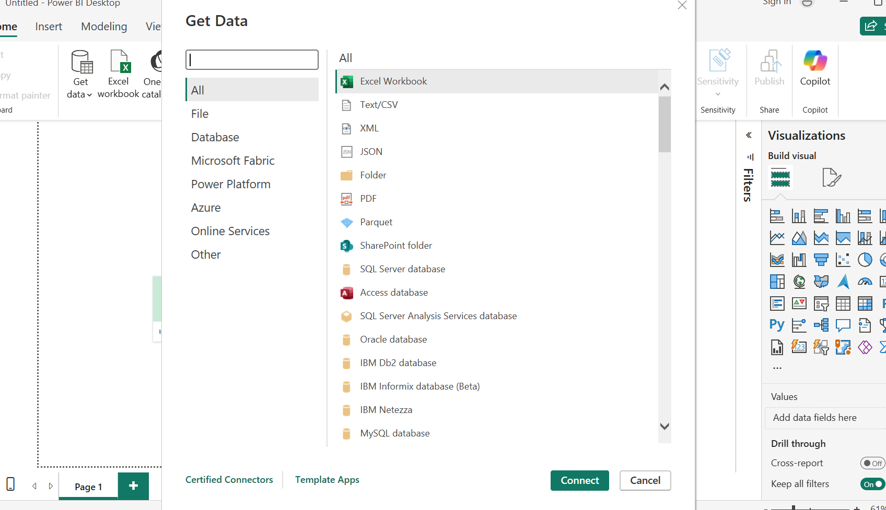  
  
Configured necessary server and database connection settings  
  
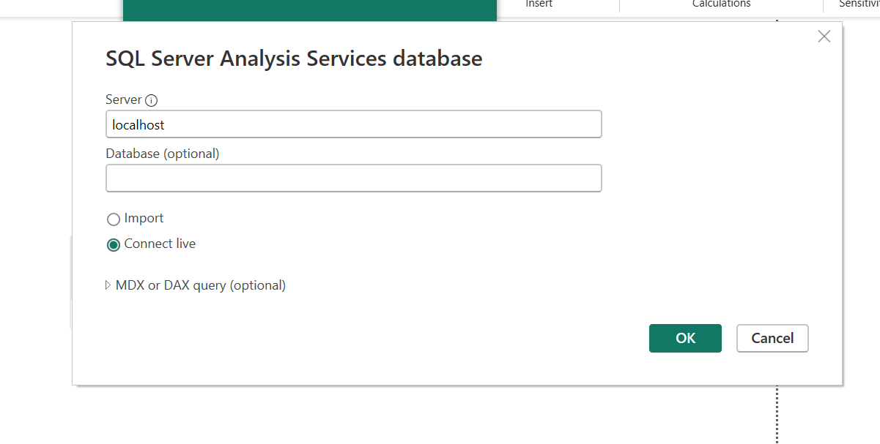  
  
Successfully loaded the SSAS cube data into Power BI for analysis  
  
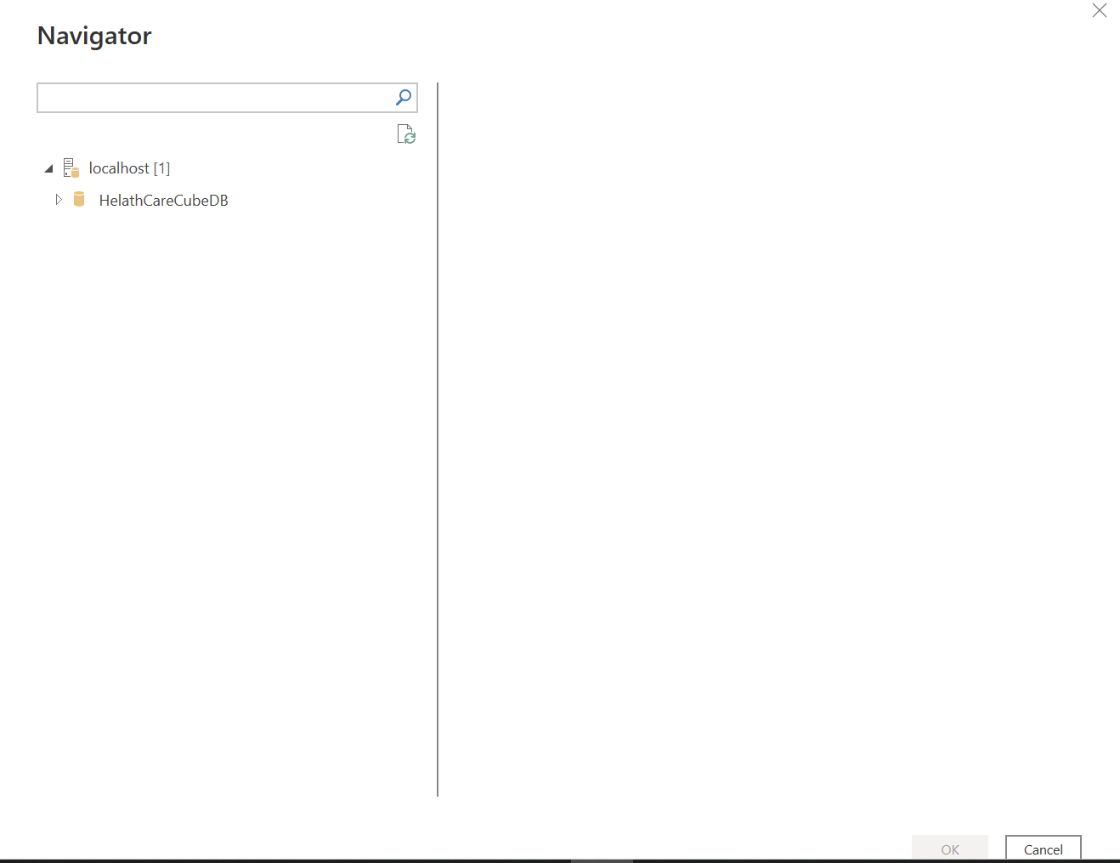  
  
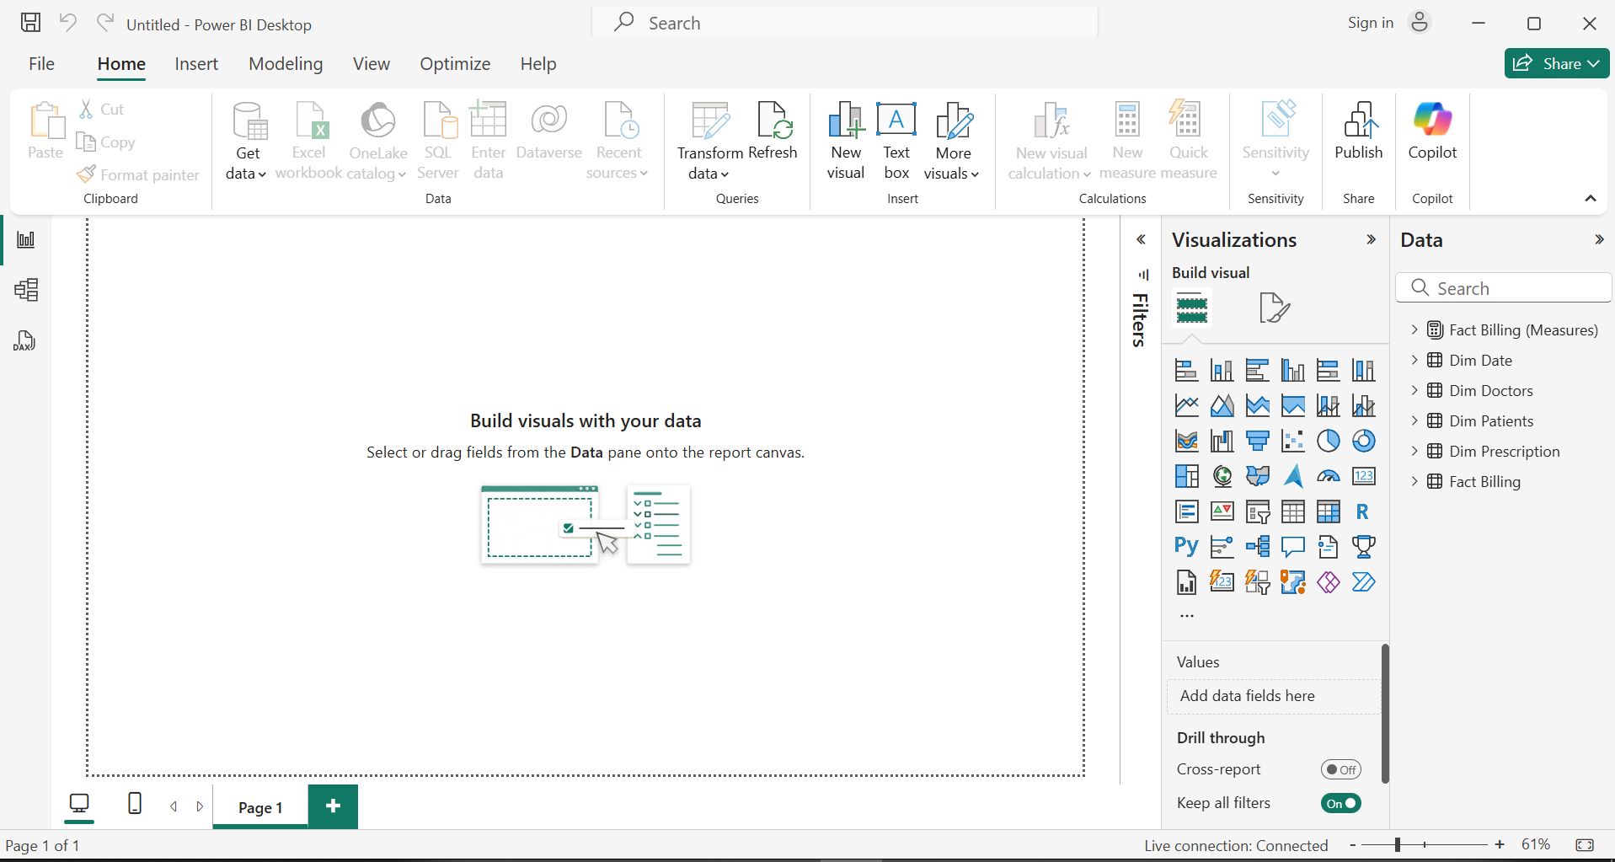

Report 1

Created a Matrix visual to display detailed tabular data with row and column fields, enabling user to analyse multilevel data in structured format  
  
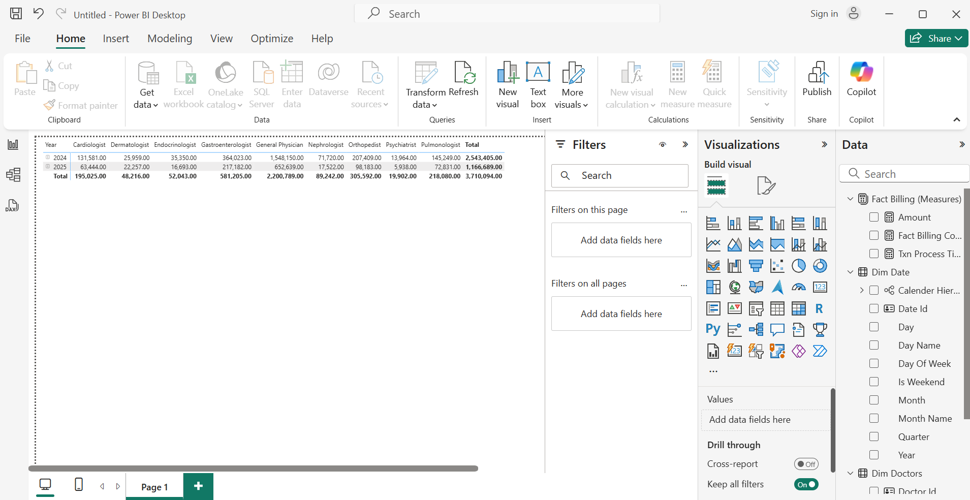  
  
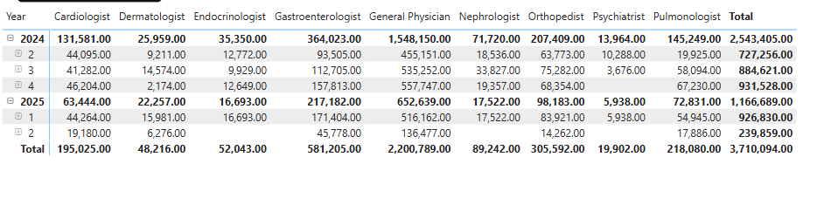

## Report 2

Designed Bar and Pie chart visuals  
Applied cascading filters to allow dynamic interaction, where selecting one filter (Doctor or Specialization) shows relevant data on Bar chart and the Pie chart  
  
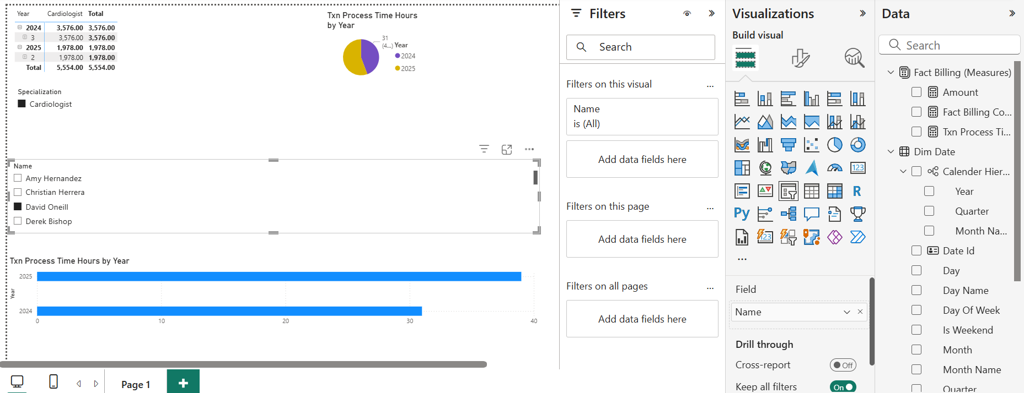  
  
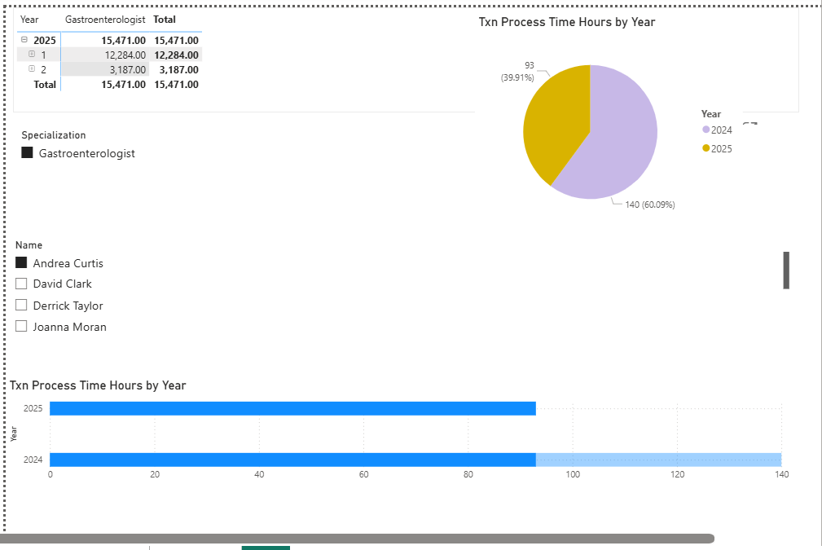

Report 3  
  
built a Bar Chart for billing counts over time using the Date Hierarchy. Enabled Drill-Down functionality, allowing a viewer to navigate from Year > Quarter > Month to explore trends in billing cycles  
  
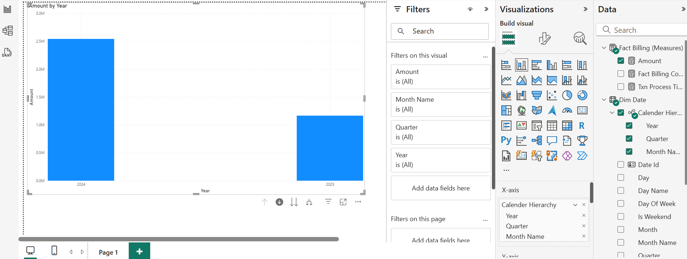  
  
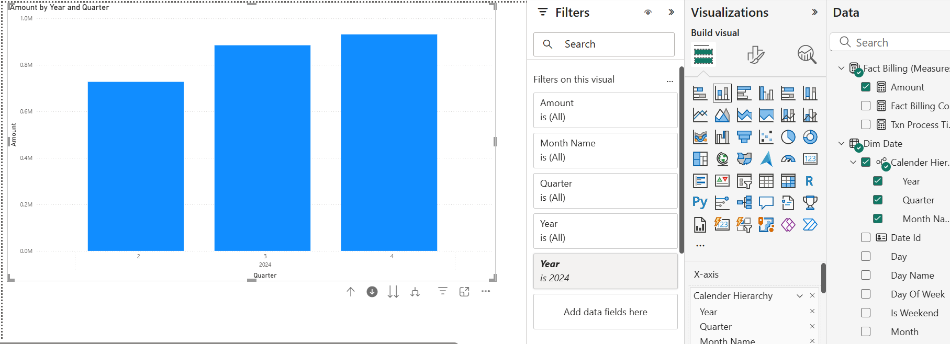  
  
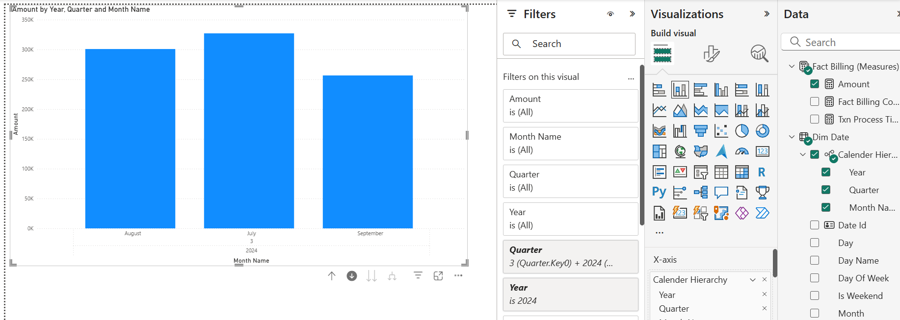

Report 4  
  
Created a separate report page featuring a Doctor-Amount Matrix. In next page created a pie chart which shows billing count and sickness type of each doctor and added Drill through filter on Doctor name in this page.   
  
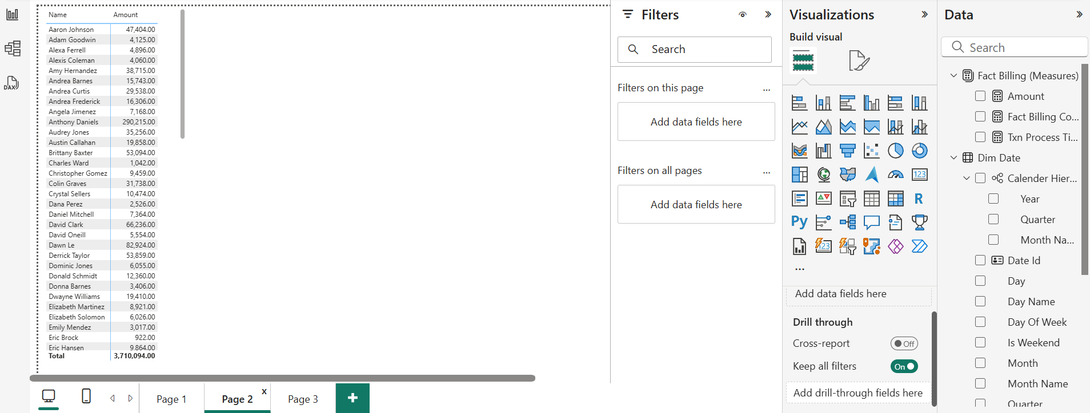  
  
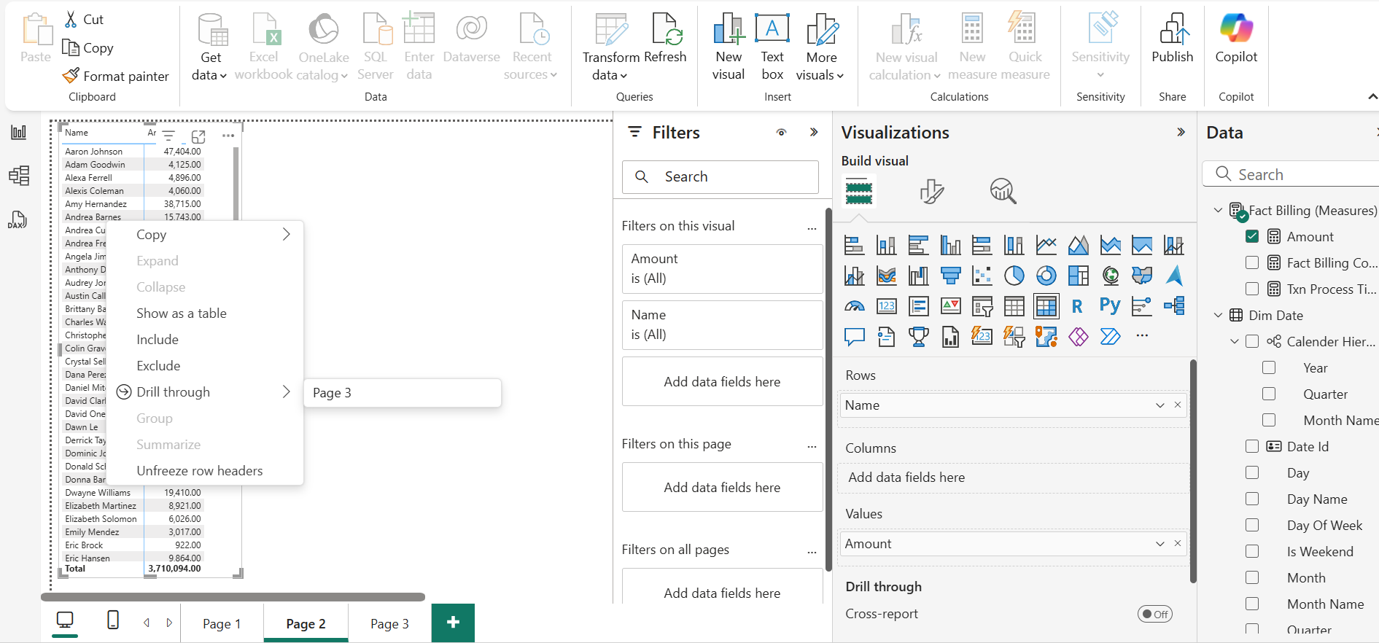  
  
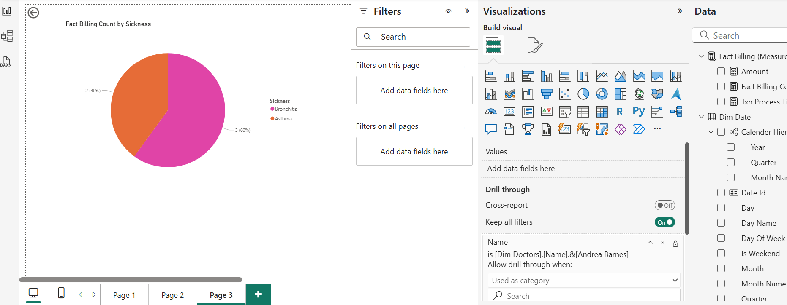

*** End Of Report ***